- List and describe each of the four ways the Duration of a Move block can be set.
- What is the difference between the Brake and Coast settings in a Move Block’s Next Action?
- If Ziffle’s Tribot travels 15cm with a duration setting of 500 degree, what duration setting should be used to have the Tribot travel 50cm?
- Describe how a tribot would behave with this program (include 4 facts):
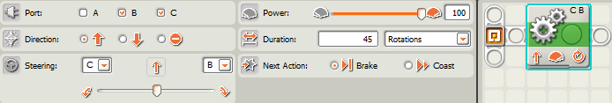
- Describe how a tribot would behave with this program (include 4 facts):
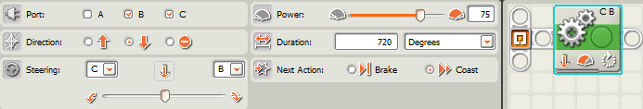
- Describe how a tribot would behave with this program (include 4 facts):
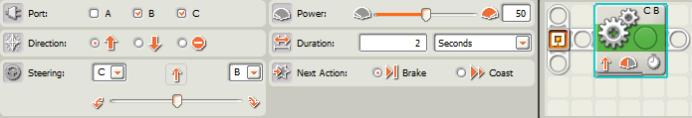
- Describe how a tribot would behave with this program:
